Project Awesome 3D Runner

Trello Link: https://trello.com/b/1xGgfL8i/3d-runner

Project closing report version 0.01

Contents:

1. Project Description
2. Results of the Project
3. General Evaluation of Project Progression
4. Experiences of the Tools and Methods
5. Personal Experiences and Evaluation
   1. Shane
   2. Patrick
   3. Oubine
   4. Fares
6. Self-Evaluation of the Module
   1. Shane
   2. Patrick
   3. Oubine
   4. Fares

1 Project Description:

The aim of our project was to create a fun and innovative game based on the mobile endless runner genre of games (Subway Surfer, Temple Run etc.) Our goal was to combine low-poly child friendly aesthetics with an ever-darkening area that progressed alongside speed and difficulty.

Due to Shane and Patrick’s previous experience with unity game building as well as the innovation and creativity of Oubine and Fares the project started very well. The game has been mostly completed when compared with our initial goal with only some minor features falling by the wayside.

2 Results of Project

Our game consisted of a colourful menu system and music combined with a settings page, shop menu and highscore screen not to mention the actual endless running gameplay and the game over screen (pictures below)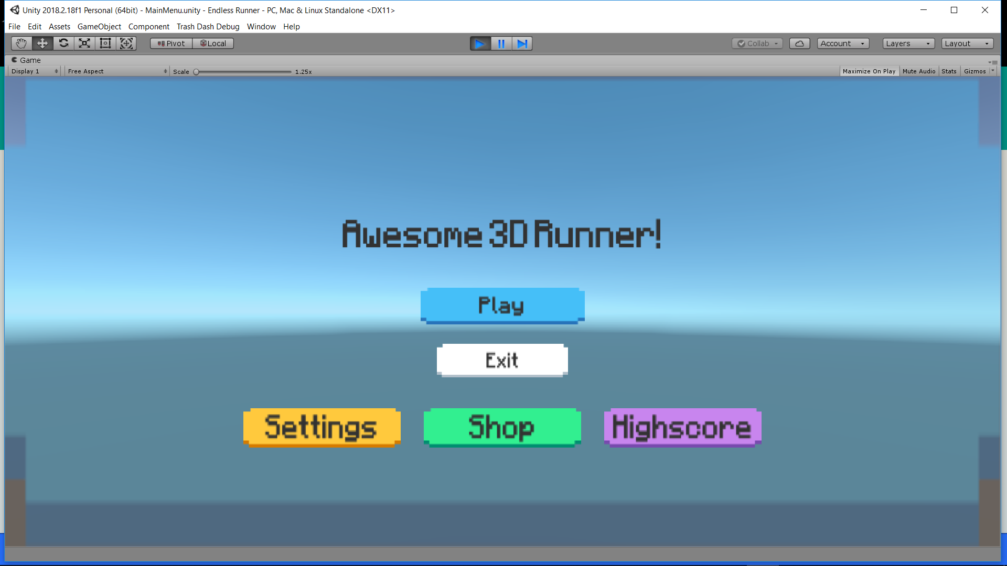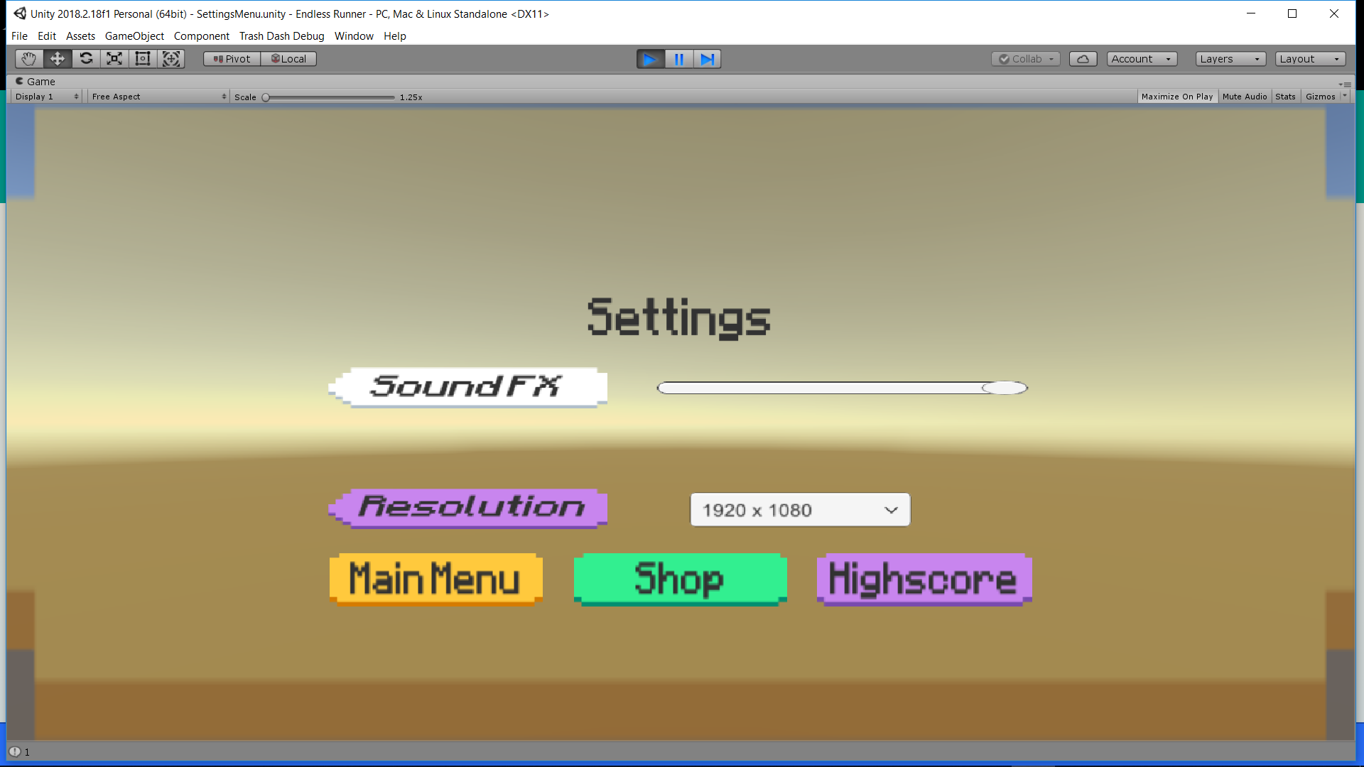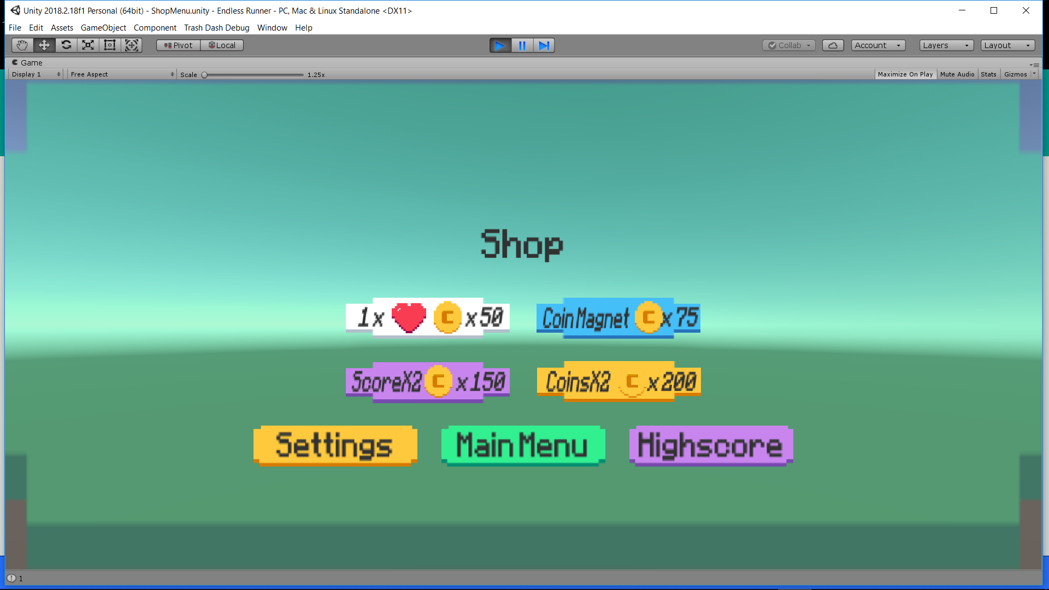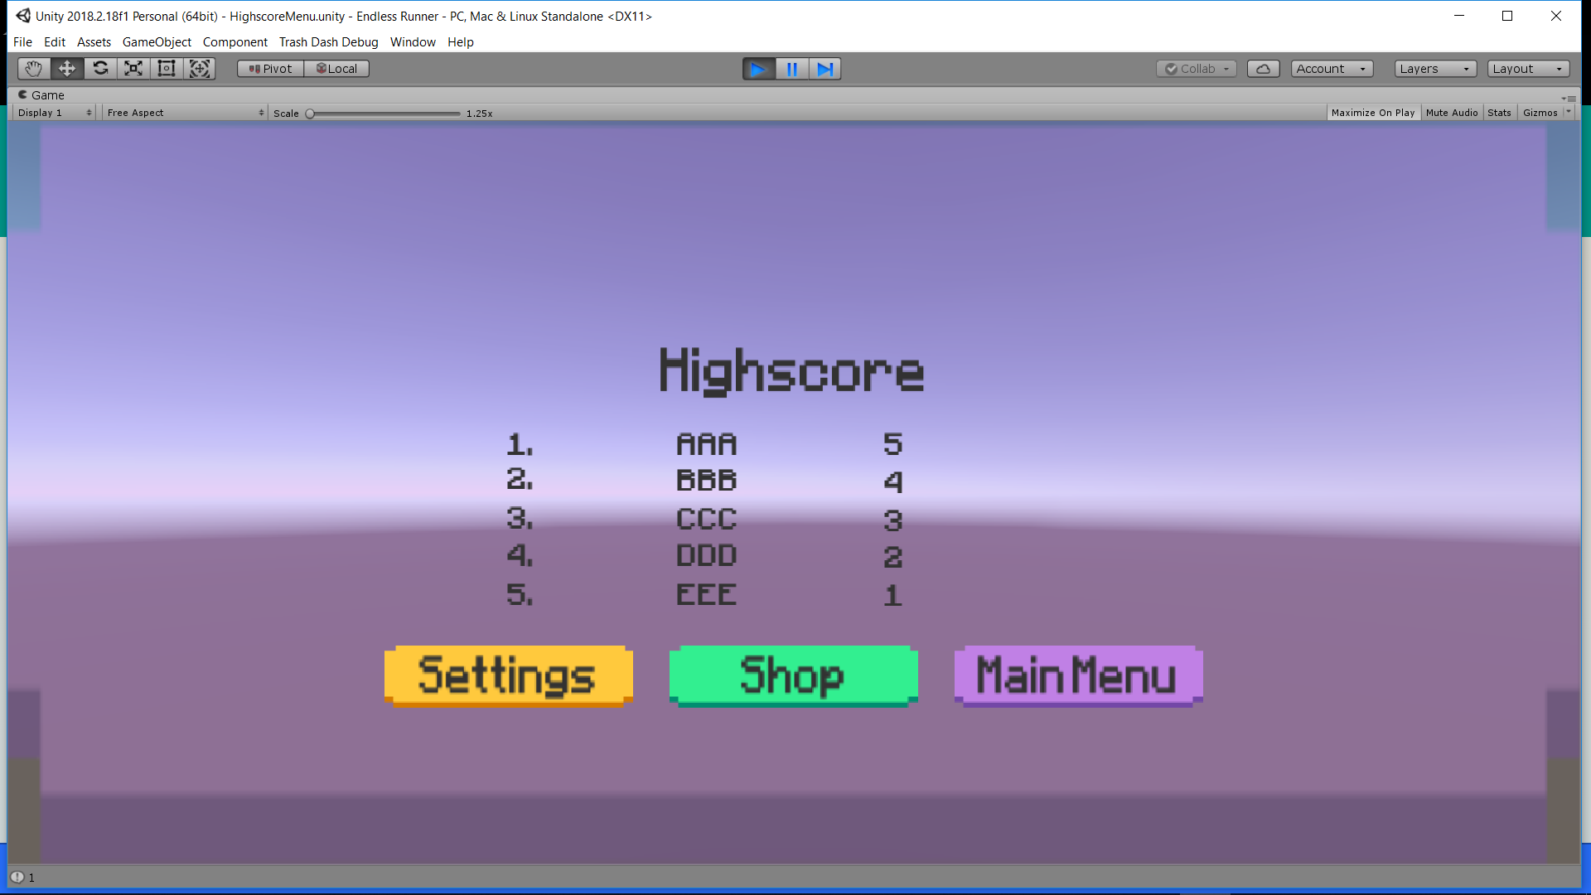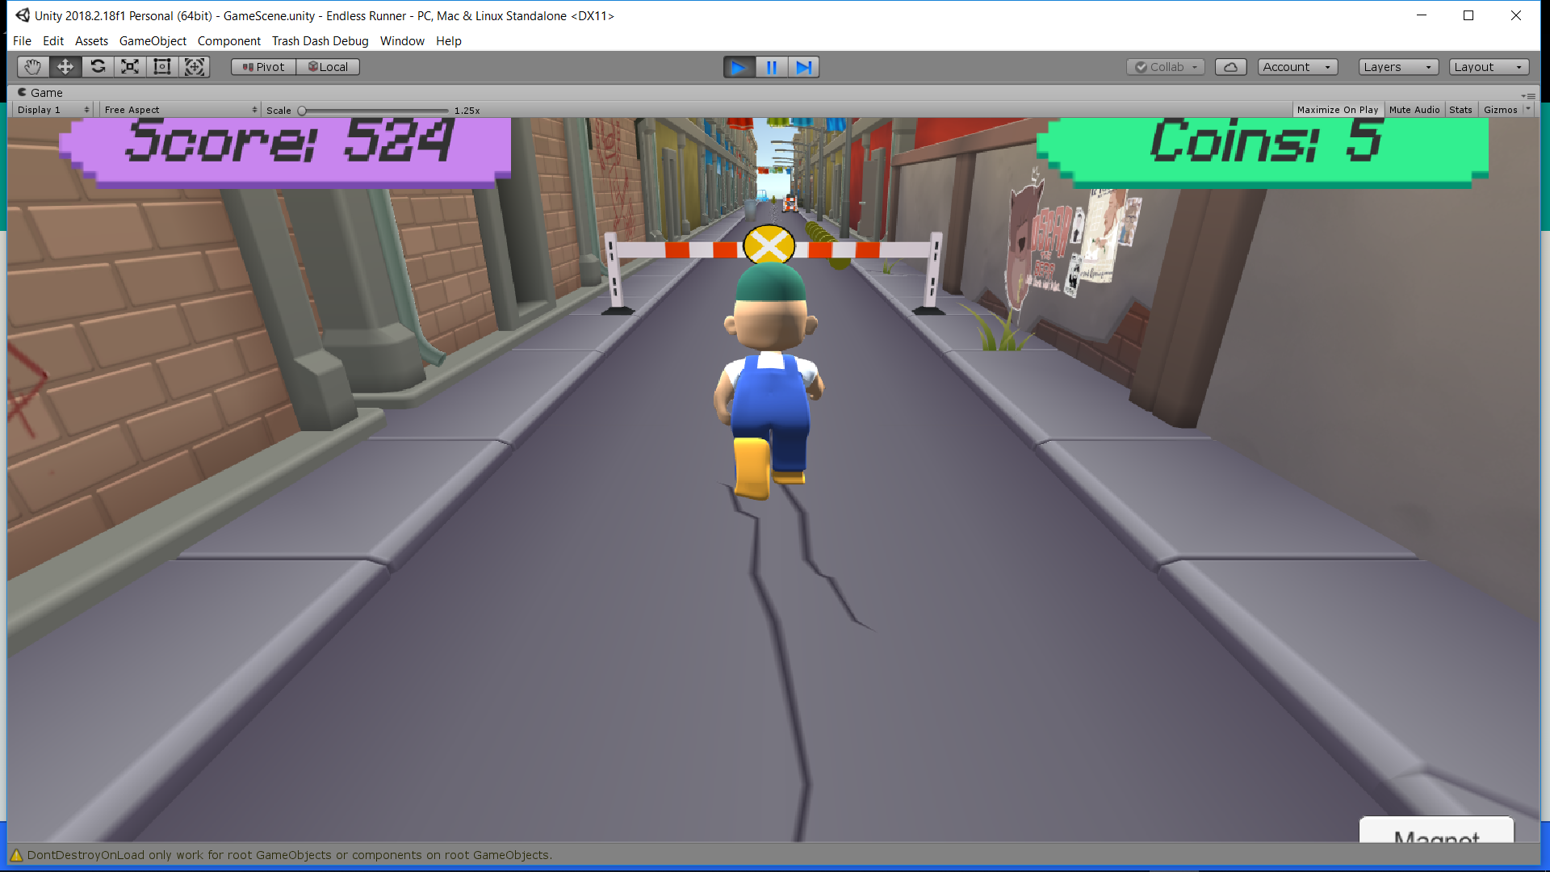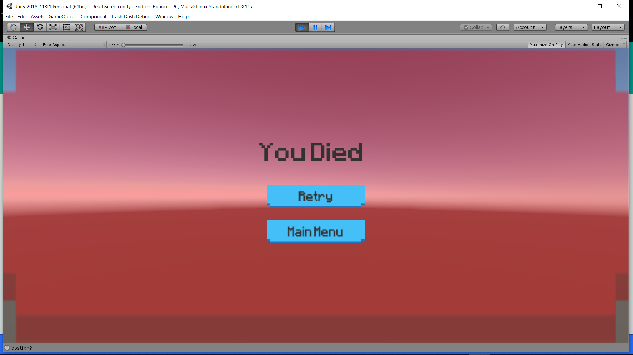

We utilised many aspects of unity and its many systems including its UI some assets from the store, a character created in blender and coded in C#.

3 General Evaluation of Project Progression

We Believe our project went very well and although not perfectly according to our plan we think that our idea has been realised for the most part. There was some delays due to lack of experience for members building this type of game and also from problems incurred whilst coding. However through perseverance our project has been completed and we are very happy with the results.

4 Experiences of the Used Tools & Methods

Mostly this was a new experience for all of us as although having previously used unity to develop 2d games Patrick and Shane had never developed a 3d game before and so utilised some of unity’s features for the first time in order to take their game development from 2d to 3d. This was also Oubine’s and Fares’ first time using github as well as blender and trello so overall there was an initial learning curve for the entire group at the start of this project but we believe it has helped us to grow as programmers and developers.

5 Personal Experiences & Learning

Shane – I really enjoyed this Project, I have never developed a game in a team or worked on a 3d game before. My main role was to help Patrick with some of the gameplay code however I was mainly focused on UI and making the game look appealing. Over the course of the project I learned a lot about UI and how to design a good UI in unity using the tools provided. I of course got assets from the unity store to assist me with keeping a running theme throughout the game. The menu aesthetic and gameplay aesthetic combined with the character model fit together very well in my opinion and really nails home the look we were going for with this game. I believe our teamwork was very useful as we all had our own designated tasks but we could always reach out to another team member if we needed help and everybody was always giving progress updates.

Patrick – i found this project to be a really interesting one. I have never worked on a project like this before with a team and it was a really interesting experience. My main role was writing the gameplay code for the game. I found it very interesting as I had never worked on a 3d game in unity before so it required learning a lot of new things in c# as well as in the unity engine, and at points it tested my problem solving abilities quite hard. I also gave input in different areas of the project when my teammates were stuck or just wanted some advice. I think for the most part we worked really well as a team, everyone in the group always tried to help each other with everything they needed and we were always keeping each other up to date about our ideas and our progress.

Oubine – The idea of the project was really funny but we had to use some completely new for me and I’m absolutely not used to be that free in my work. So I thought that I could choose to learn to use Blender to create a nice looking game and add our touch in the game. Moreover I wanted to learn how to do 3D modelling for a while, so that was the perfect occasion for me. But Blender is a software quite difficult to master, it took me some time at the beginning to learn everything by myself and I did some mistake. Even after, I had to do a lot of research by myself to fix my problem on my own. That’s why I reduced my ambitious of the beginning. But I’m glad to finally know how to do 3D modelling.

For the team working, I always let my partners know where I was in my work and they always let me informed of theirs advancement, so that was a great group. We all had our own task.

Fares – I was mainly in charge of the environment and surroundings of the player. To do the design (3 Line track and buildings), we imported an asset called Endless Runner – Sample game from the unity Asset Store. Then we dragged all the materials needed into the scene with the same x and y positions and merged all the materials into one prefab. We also imported a skybox from the unit Asset Store, and with it we managed the lightning (darkness) of the game since the environment becomes progressively darker.

6 Self-Evaluation of the Module

Shane – I’m very happy with how this project has turned out despite us not reaching all of our goals. I think each member of the team brought something valuable to the table and I believe a middle of the road grade such as a grade would be appropriate as we did not complete all of our goals, but we did complete most of them and definitely got our point across with the design and aesthetic of the game, which was the main spark behind the idea of this project.

Patrick – I think the project turned out well, although we didn't reach the goal we wanted to reach. Everyone on the team brought something different to the table in terms of skillset and ideas. I think everyone in the group learned a lot despite not getting it over the line at the end. With that in mind i think the team deserves a middle grade, as although we didn't get it finished we have most things completed and everyone learned a lot of new skills in the process.

Oubine – I learned a lot during this project to work on my own and in total autonomy. Moreover, I learnt to work in a multicultural environment which wasn’t the easiest. But at the end I think that the game is fine and we all participated as we could. So I think that an average grade like 3 would be fair

Fares - I think that we managed to almost completely finish the game with all the functionalities needed. In addition, the project was very useful since I was always interested in video games. I also learnt a lot about unity, designing and building mainly and a little bit of c# language. I believe a grade 3 or 4 would be deserving.